Ankita Durgude

**Assignment –4**

**Retrieving Information from Tables.**

1) Write a select command that produces the order number, amount, and date for all

**rows in the Orders table. Ans:** select Onum,Amt,Odate from ORDERS;

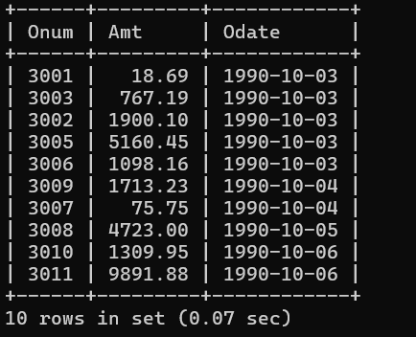

**2) Write a query that produces all rows from the Customers table for which the**

**salesperson’s number is 1001.**

**Ans:** select * from Customers where Snum=1001;

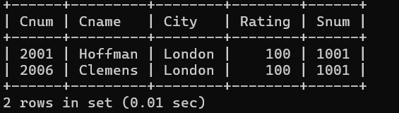

**3) Write a query that displays the Salespeople table with the columns in the**

**following order: city, sname, snum, comm.**

**Ans: select city, sname, snum, comm from Salespeople;**

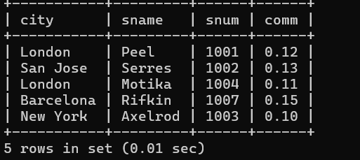

**4) Write a select command that produces the rating followed by the name of each**

**customer in San Jose.**

**Ans:** select rating,cname from CUSTOMERS where City='San Jose';

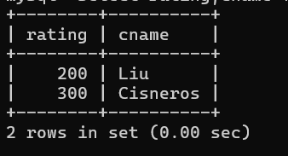

5) Write a query that will produce the snum values of all salespeople (suppress the

**duplicates) with orders in the Orders table.**

**Ans: select distinct snum from Orders;**

